Leeuwin Scholarship Information Pack
Application Process
The Shire of Dandaragan and Shire of Coorow will be offering two fully funded scholarships for the 2024/25 financial year. One recipient will be selected from each of the two Shire’s. Applications open 1 April 2024 and close on 10 May 2024.
The purpose of the Leeuwin Ocean Adventure Scholarship is to provide young people of the Shire of Dandaragan and Shire of Coorow the opportunity to experience personal and leadership development through the hands-on experience of a 7-day sailing voyage.
The Leeuwin Voyages are also endorsed by the Curriculum Council of WA. Young people in Years 10, 11 and 12 can earn 5 WACE points towards their graduation.
Under the Leeuwin Scholarship, the Shire of Dandaragan and Shire of Coorow will fund the entire cost of the voyage (up to $2,500 per person) for two young people who meet the eligibility criteria below.
Eligibility Criteria
- Must be aged 15 – 18 years old.
- Must be a resident of the Shire of Dandaragan or Shire of Coorow (or have parents residing in one of the Shire’s).
- Must have written support from a teacher, mentor, employer, or community group member. A support letter should include information on the young person and how this will benefit their academic performance, personal development and/or other factors.
- Must submit a complete application form.
- Must submit a video or a written response explaining why you would like to be chosen to attend the Leeuwin Ocean Adventure.
- Must make a commitment to attend if selected.
- May be required to present to Council following their Leeuwin Adventure and report on what they have gained from their experience.

What happens next?
Applications received will undergo a selection process. All young people are notified, whether successful or not. The Shire of Dandaragan and Shire of Coorow may publish an article on the successful applicant.
Comments from Previous Participants
Leeuwin Scholarship Successful Applicant Alliyah Narrier
Although I got a little sea sick, I had the best experience! The Leeuwin voyage was so fun and challenging. The environment was great, the people were great and so was the food!! Such a good way to get to know new people and do something that is a little out of your comfort zone.
Leeuwin Scholarship Successful Applicant Julie-Anne Carlson
I went on the 7 day Leeuwin adventure and it was one of the most difficult weeks of my life, but with hard work and persistence, the rewards at the end of the week were definitely worth it! It’s a once in a lifetime experience for sure.
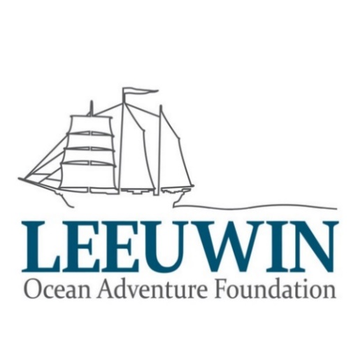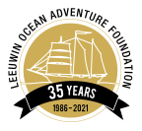

Leeuwin Scholarship Application

FULL NAME: ______________________________________________________

School/Educational Institute/Workplace (if applicable):

DATE OF BIRTH: ________________ AGE: _______

HOME ADDRESS:

Street number: __________________________________

Street name: __________________________________

Suburb/town: __________________________________

Post code: _________________

CONTACT NUMBER (ph): ________________________________

EMAIL ADDRESS: ___________________________________________________

PARENT GUARDIAN NAME: __________________________________

PARENT GUARDIAN CONTACT NUMBER: ________________________________

PARENT GUARDIAN EMAIL ADDRESS: ____________________________________________________________________

How did you hear about the Shire of Dandaragan Leeuwin Scholarship?
____________________________________________________________________

Create a one-to-two-minute video or write your answer below, explaining why you want to take part in the Leeuwin Youth Adventure Voyage. (e.g. skills you want to develop / goals you want to work on / experience you want to share with your community) Also, explain why you would make a suitable candidate:
________________________________________________________________________________________________________________________________________________________________________________________________________________________________________________________________________________________________________________________________________________________________________________________________________________________________________________________________________________________________________________________________________________________________________________________________________________________________________________________________________________________________________________________________________________________________________________________________________________________________________________________________________________________________________________________________________________________________________________________________________________________________________________________________________________________________________________________________

Have you provided written support from a teacher, mentor, employer or community group member? (circle)
Yes No

If successful, do you agree to present to Council following your Leeuwin Adventure? This will provide useful feedback on the Leeuwin program. (circle)
Yes No

The successful applicant must complete their Leeuwin Voyage between 1 July 2024 and 30 June 2025.
I declare that all information provided in this form is true and correct:

Signed _________________________________________________________

Print Name: ____________________________________________________

Date: __________________

Parent/Guardian signature: ________________________________________

Parent/Guardian Name: ____________________________________________

Date: __________________

